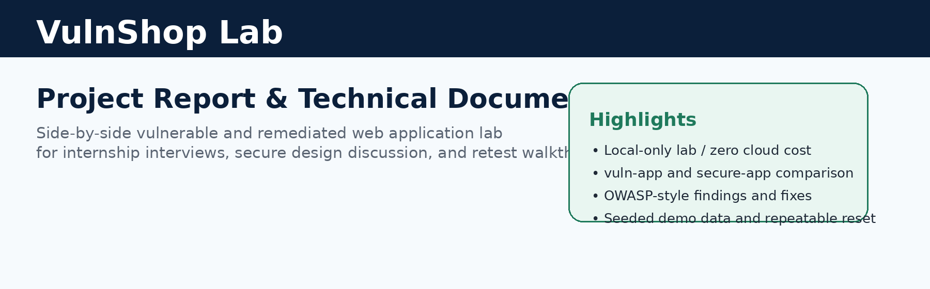
Project type  Technical portfolio report | Primary stack  Node.js, Express, SQLite, Docker | Cost profile  £0 local run / no AWS required
Scope  Local-only security learning lab | Comparison model  vuln-app vs secure-app | Primary use  Internship interview walkthrough

1. Executive summary
VulnShop Lab is a side-by-side web application lab created to demonstrate both offensive and defensive security thinking in a portfolio-friendly way. The uploaded archive contains two versions of the same e-commerce application style: a deliberately vulnerable build for controlled local testing and a remediated, secure build for comparison and retest.
The strongest interview value comes from the comparison model. Instead of showing only that a vulnerability exists, the project shows how the issue appears in code, what business risk it creates, how the control is implemented, and what should change when the test is rerun against the secure build.
Why this project stands out
It is practical, repeatable, low-cost, and easy to explain. The lab runs locally, uses seeded demo accounts, and covers a broad set of interview-relevant web risks, including SQL injection, cross-site scripting, broken access control, SSRF, insecure file uploads, weak session handling, weak secret management, missing rate limiting, and validation/error-handling gaps.
2. Source material reviewed
Material | Purpose of this report | Examples used
Root README and compose file. | Confirm ports, run model, seeded accounts, and local-only scope | docker-compose.yml, package.json, README.md
Route handlers and middleware | Validate where vulnerabilities and fixes exist | auth.js, orders.js, profile.js, fetch.js, admin.js, support.js
Database setup and seed scripts | Confirm the fake data model and account list | src/db/database.js, src/db/seed.js
Provided screenshot | Show the current secure build user interface | Secure products page image shared in chat
3. Architecture and lab design
The project is intentionally simple: both application variants expose nearly the same business features and run only on localhost. This makes it easy to compare behaviour without incurring extra cloud costs or introducing infrastructure noise. The Docker configuration binds the vulnerable build to 127.0.0.1:3000 and the secure build to 127.0.0.1:3001, with separate local data stores and seeded demo content.
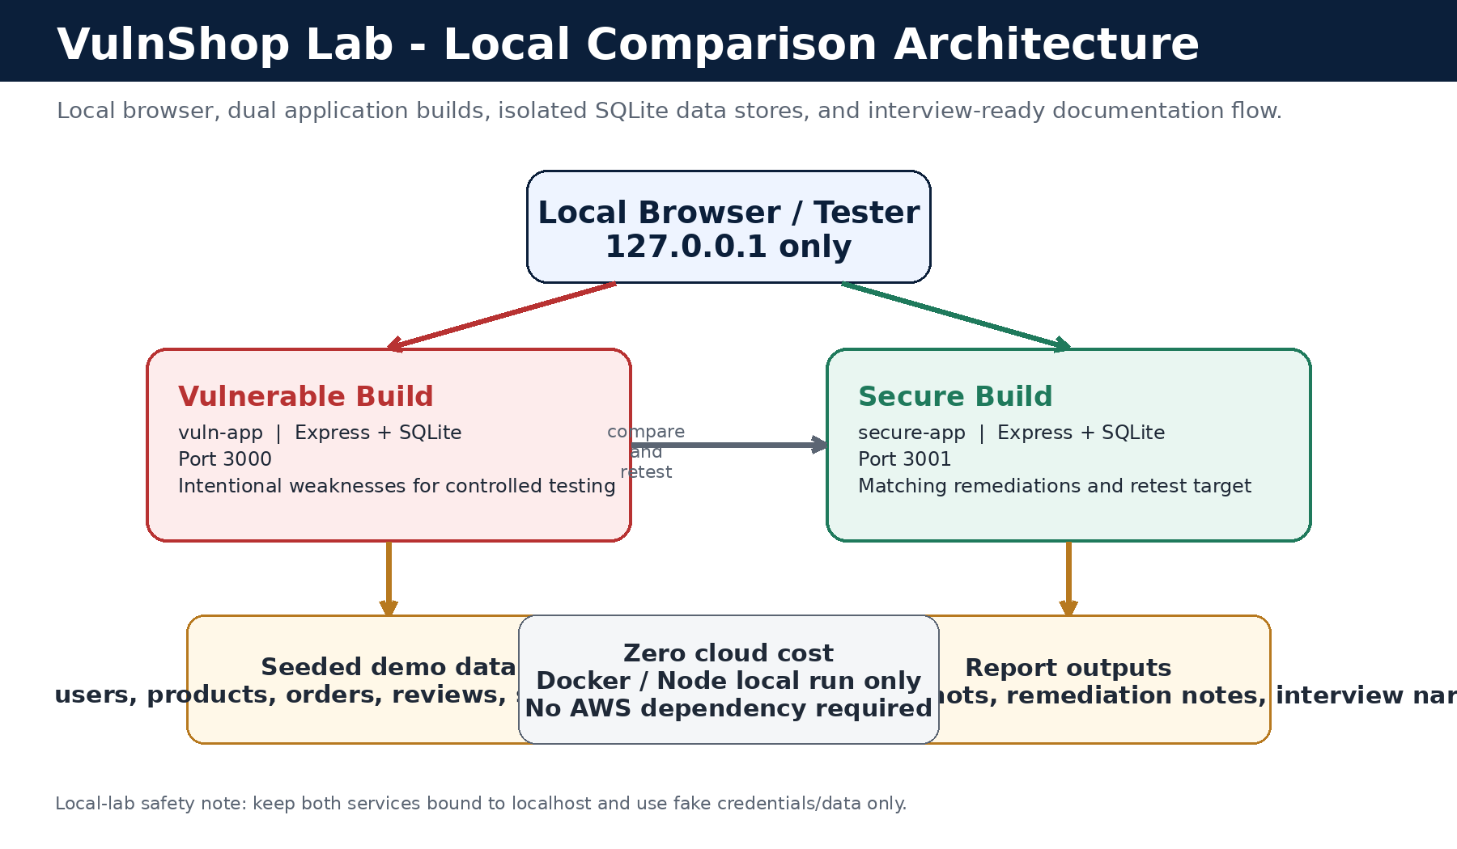
Figure 1. Local comparison architecture for VulnShop Lab.
Local-lab constraint
This report treats the project as a private educational environment only. The application should not be publicly exposed, use only fake/demo data, and not require any paid cloud resources or AWS services to remain valuable for interviews.
4. Product and UI overview
The application theme is a small online store with login, registration, product browsing, reviews, cart and order history, profile management, support tickets, an admin area, and a server-side URL fetch feature. That feature set is broad enough to expose common web security weaknesses while still staying understandable for a first-year student presenting the work.
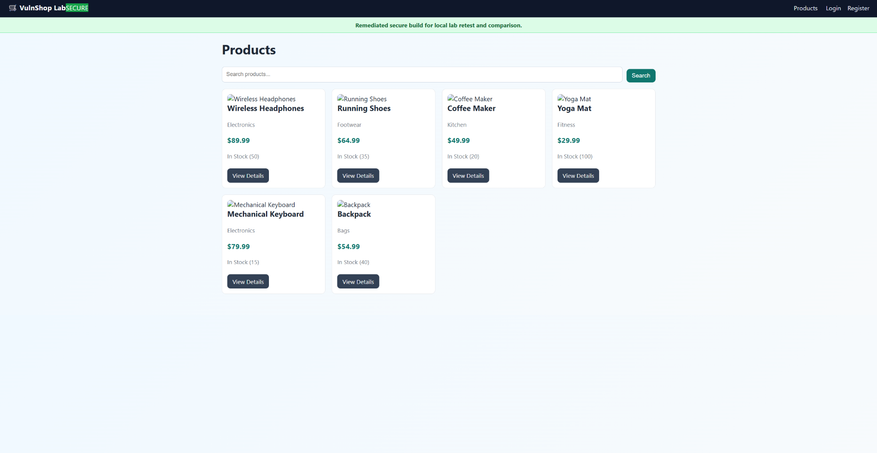
Figure 2. Secure the build products page provided by the user during review.
5. Security objectives and methodology
Area | Objective | Representative vulnerable behavior | Expected secure outcome
Injection | Prevent unsafe queries and hostile input execution | String-built SQL queries and unsafe rendering paths | Parameterised queries, escaped output, bounded input
Access control | Ensure only the right user can reach sensitive records | Order/profile/ticket exposure without strong ownership checks | Per-route owner or admin authorisation enforcement
Auth & session | Protect login flow and session state | No throttling, session fixation risk, weak cookie settings | Rate limiting, session regeneration, safer cookie policy
Server-side requests and uploads | Restrict dangerous backend actions | Arbitrary URL fetching and permissive upload handling | Host allowlist, protocol restrictions, MIME/size validation
Operational hygiene | Reduce leakage and insecure configuration | Hardcoded secret and verbose error responses | Environment-based secrets and generic safe errors

6. Finding summary matrix
ID | Finding | OWASP-style theme | Representative evidence in vuln-app | Secure control in secure-app
F1 | SQL injection | Injection | Login, registration, product search, and admin search build SQL with string concatenation. | Parameterised queries and schema validation
F2 | Stored/reflected XSS | Injection/output encoding | Unescaped template rendering plus unsanitized review and bio fields | Escaped EJS output and bounded comment/profile input
F3 | Broken access control / IDOR | Broken access control | Orders, profiles, and support tickets can be viewed without strong ownership checks. | Owner/admin checks on sensitive routes
F4 | Weak authentication and session handling | Identification and authentication failures | No login throttling, session fixation risk, plaintext password flow | Rate limiting, bcrypt hashing, session regeneration, safer cookie settings
F5 | Hardcoded secret management | Security misconfiguration | Session secret embedded in source code | Environment-based session secret loading
F6 | Insecure file upload handling | Security misconfiguration | No MIME filter, no size limit, original filenames kept | Allowlisted MIME types and upload size limits
F7 | Server-side request forgery | SSRF | Arbitrary URL fetch with redirect following and verbose error feedback | Strict hostname allowlist, protocol checks, and redirect blocking
F8 | Missing brute-force protection | Authentication hardening | Login accepts repeated attempts without throttling | Auth route rate limiter
F9 | Validation and error leakage gaps | Secure design/logging hygiene | Verbose errors reveal internals, and many routes accept unbounded data | Joi validation and generic error handling
F10 | CSRF exposure on support submission | Request integrity | Support submission accepts cross-site requests without checks | Same-origin request enforcement on the support form
7. Representative detailed findings
F1/F4. Login flow: injection and session hardening
Risk summary: A vulnerable login path can permit authentication bypass or allow an attacker to reuse a fixed session after login.
Vulnerable implementation | Secure implementation
• Username and password are concatenated directly into a SQL query string.  • No rate limiting is applied to repeated login attempts.  • The session is not regenerated on successful login.  • The vulnerable build also stores or compares passwords in weaker ways than the secure build. | • Login input is validated before database interaction.  • User lookup uses a parameterised query.  • Password verification uses bcrypt hashes.  • The session is regenerated after successful authentication, and the secure build applies rate limiting.
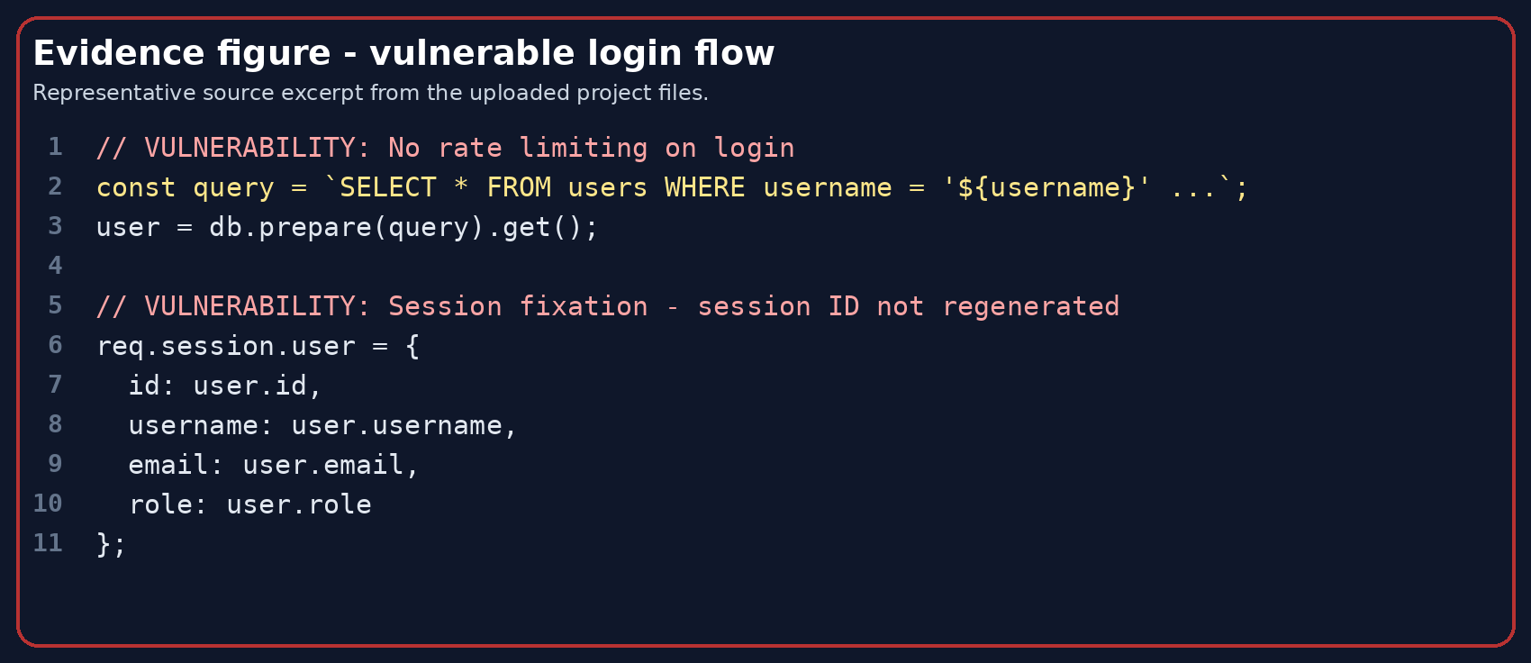
Figure 3. Representative vulnerable login excerpt from auth.js.
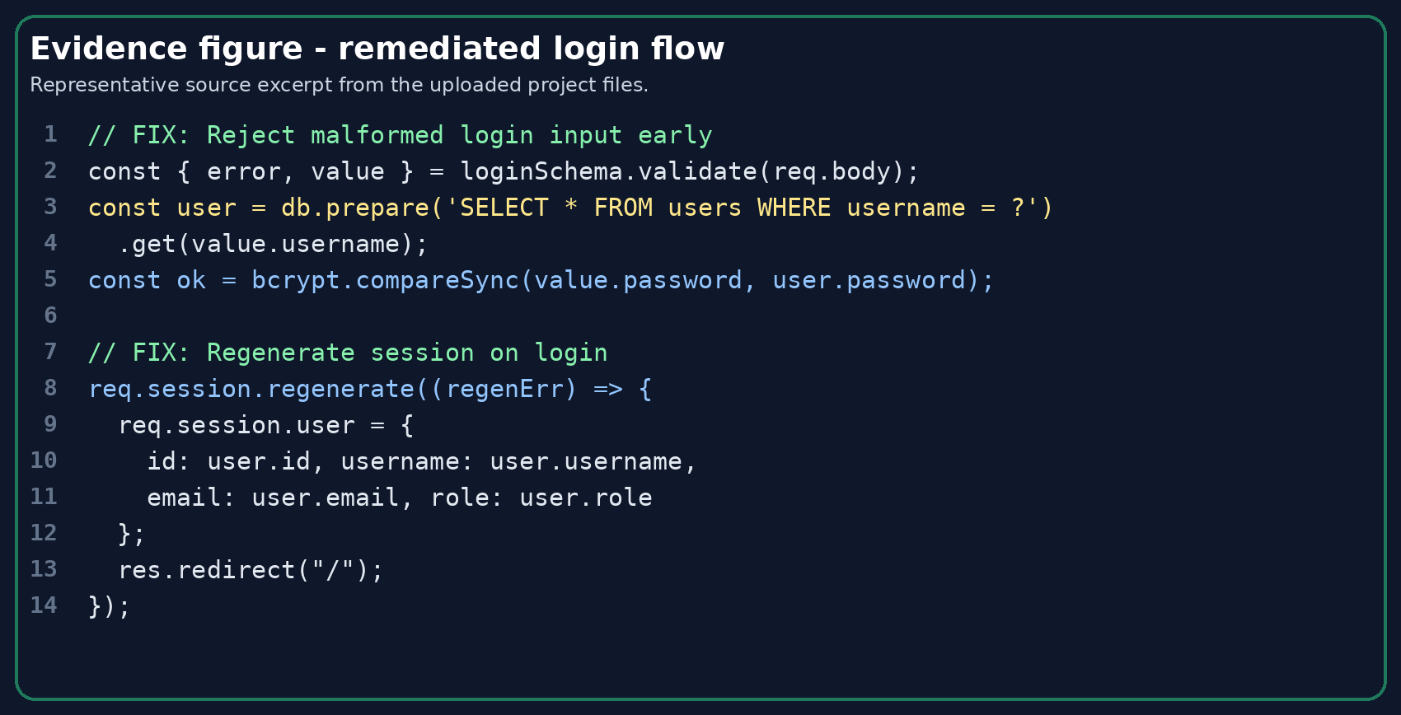
Figure 4. Representative secure login excerpt from auth.js.
F3. Broken access control and insecure direct object references
Risk summary: When record ownership checks are missing, authenticated or even unauthenticated users may read or manipulate data that does not belong to them.
Vulnerable implementation | Secure implementation
• The vulnerable order detail route fetches by order ID only, without binding the query to the current user ID.  • The vulnerable profile route allows broad profile access by numeric ID.  • The vulnerable support ticket listing is accessible without the intended admin-only restriction. | • The secure order route validates the ID and queries by both order ID and the current user ID.  • The secure profile route restricts access to the owner or an admin.  • The secure support ticket listing requires both authentication and admin authorisation.
F6/F7. Backend trust boundaries: upload handling and SSRF
Risk summary: Permissive server-side actions can create attack paths that do not depend on the browser, which makes them particularly valuable to discuss in interviews.
Vulnerable implementation | Secure implementation
• The vulnerable avatar upload path accepts broad file types and preserves original filenames.  • The vulnerable fetch route will retrieve arbitrary URLs and follow redirects.  • Verbose backend errors are returned to the user when fetches fail. | • The secure upload path uses an allowlisted MIME policy and a file size limit.  • The secure fetch path checks protocol and hostname against an allowlist.  • Redirects are blocked, and the error message is kept generic.
F2/F9/F10. Input handling, output encoding, and request integrity
Risk summary: These issues matter because they turn normal product, profile, and support features into browser-execution or abuse paths.
Vulnerable implementation | Secure implementation
• The vulnerable build stores review and bio content without strong input limits and uses templates that can render untrusted content unsafely.  • Several vulnerable routes return verbose internal errors that reveal stack or query details.  • The vulnerable support submission route lacks a same-origin style request check. | • The secure templates escape untrusted values and inputs are bounded before persistence.  • The secure build uses safer generic error pages.  • The support route enforces a same-origin check to reduce CSRF exposure.
8. Route map and attack surface
The route inventory is useful during interviews because it shows that the project covers multiple trust zones: public browsing, authenticated user actions, and privileged administration. That gives a natural way to explain how different control types apply at each tier.
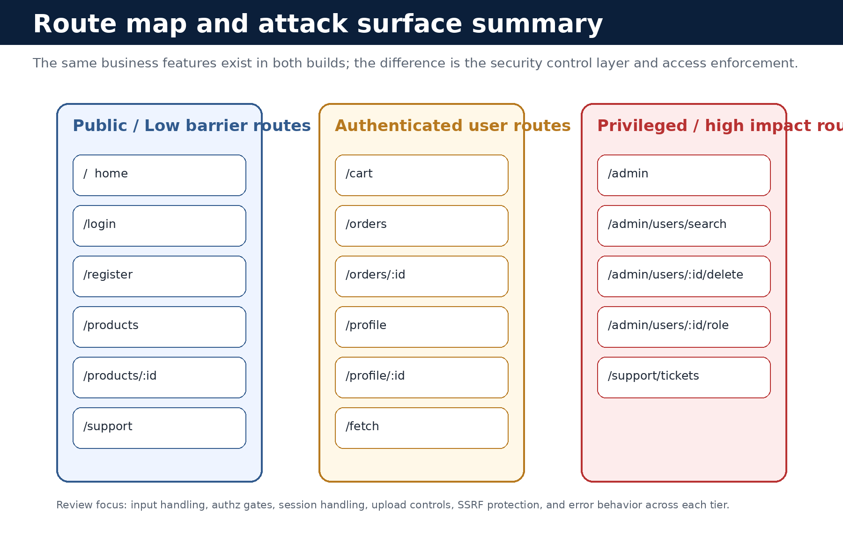
Figure 5. High-level route map used to explain the project surface area.
Category | Examples | What to discuss in an interview
Public routes | /, /products, /support, /login, /register | Validation, safe rendering, generic errors, and why public-facing pages need stronger input discipline.
Authenticated user routes | /cart, /orders, /profile, /fetch | Ownership checks, session trust, SSRF boundaries, upload safety, and secure defaults after login.
Admin routes | /admin and admin user management actions | Why privileged paths should never rely solely on a client-side or stale session claim.
9. What makes this project strong for internships
- It shows both attacker thinking and engineering discipline rather than only one side.
- It is built on a realistic web stack that interviewers can quickly understand.
- It includes code-level evidence, not only screenshots or tool output.
- It demonstrates the ability to explain why a control was chosen, not just that a vulnerability exists.
- It is inexpensive to run and easy to reset, which is ideal for repeated demos and portfolio maintenance.
10. Suggested next additions
- Capture additional screenshots for login, order detail, admin dashboard, support tickets, profile edit, and fetch tool screens.
- Create a separate pentest report that records exact localhost test cases, impact statements, and retest results.
- Add automated tests for authorisation checks, validation rules, and rate limiting to strengthen the engineering story.
- Add security logging or audit events so incident-response talking points can be introduced later.

Appendix A. Demo accounts and local commands
Username | Password | Role | Suggested demo use
alice | password123 | user | General browsing, order history, profile, support, and URL fetch examples
bob | bobspassword | user | Second-user context for authorisation checks and comparison
admin | admin1234 | admin | Admin dashboard and privileged route verification
Command |  | Purpose
docker compose up --build |  | Start both builds on localhost using the provided compose file.
npm run demo: reset |  | Reset and reseed the databases before a walkthrough.
http://127.0.0.1:3000 |  | Vulnerable build default URL
http://127.0.0.1:3001 |  | Secure build default URL

